***Module B: Development***

1.Diagrams of system requirement

|  |  |  |
| --- | --- | --- |
| System requirement | Categary | Function |
| Abseil | Mechanical Component | Drop or lift the rope |
| Mechanical Arm | Mechanical Component | Grab or drop relief goods |
| Delivery Box | Mechanical Component | Store relief goods |
| Solidworks | Software | Design components of drone |
| Qground Control | Software | Debug the drone |
| Clover Blocks | Software | Realize automatic tracking function |

2.Prototype

(1) Abseil:

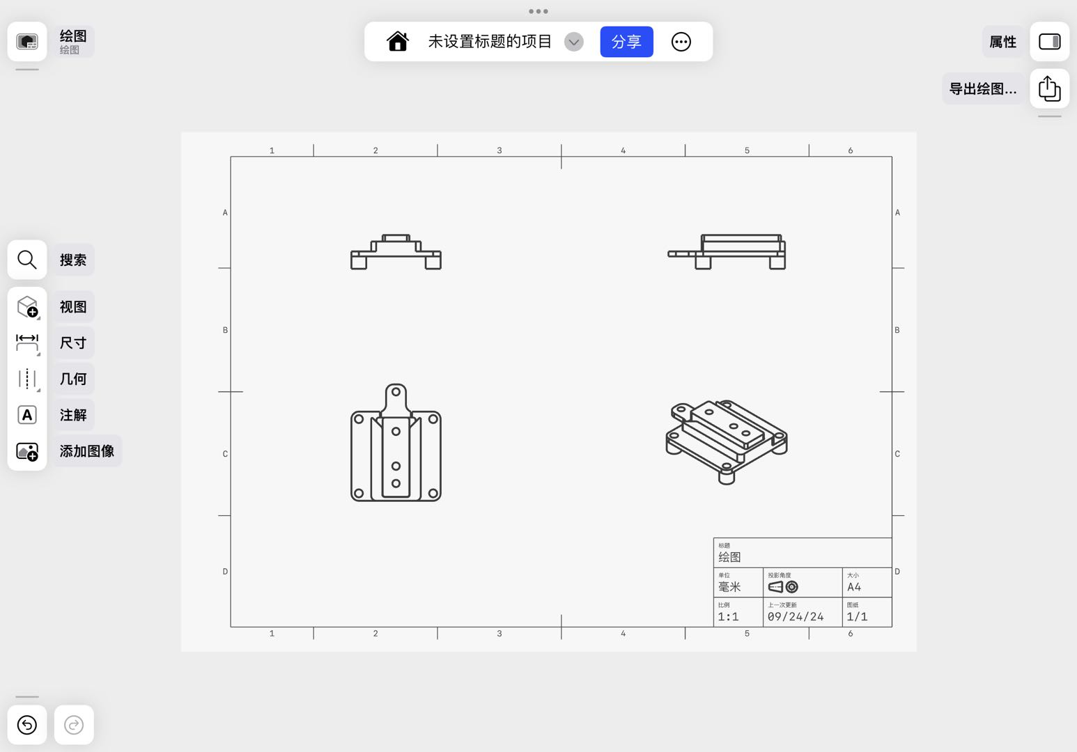1) Drawings:

Fig.1 Drawings of Closed Abseil

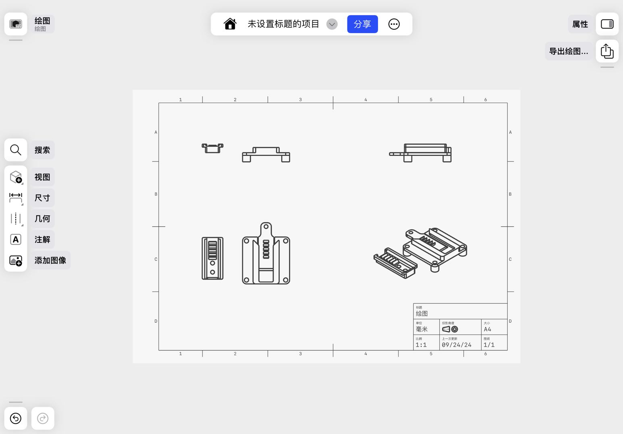

Fig.2 Drawings of Opened Abseil

2)Mockups

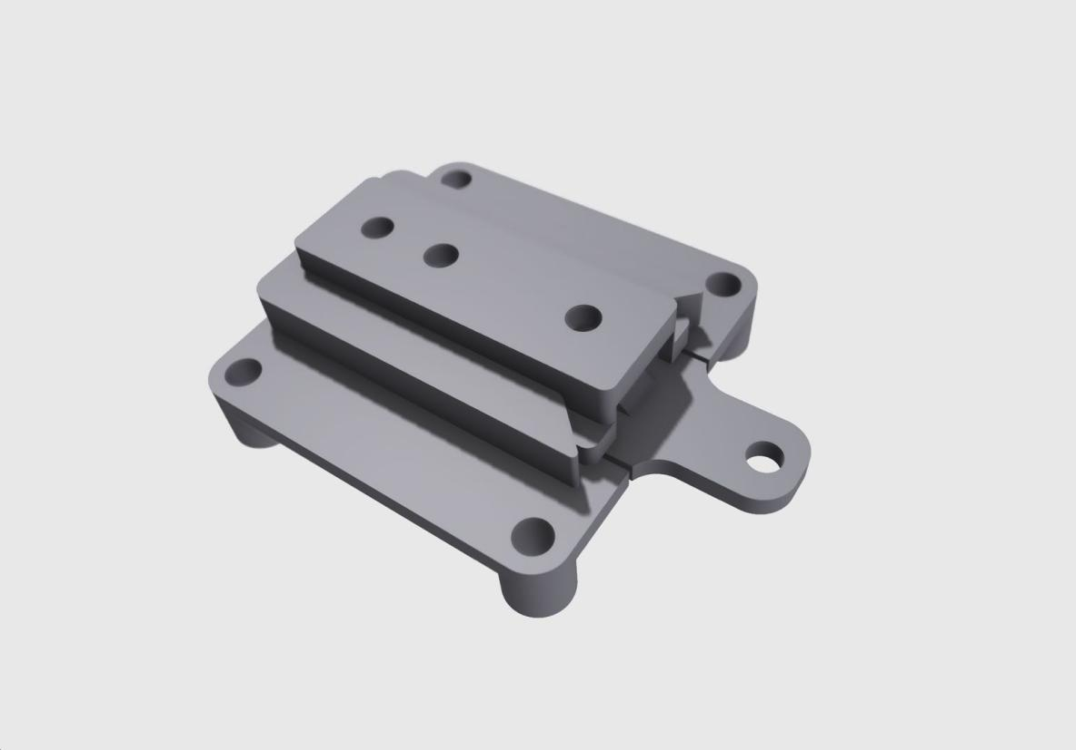

Fig.3 Mockups of closed Abseil

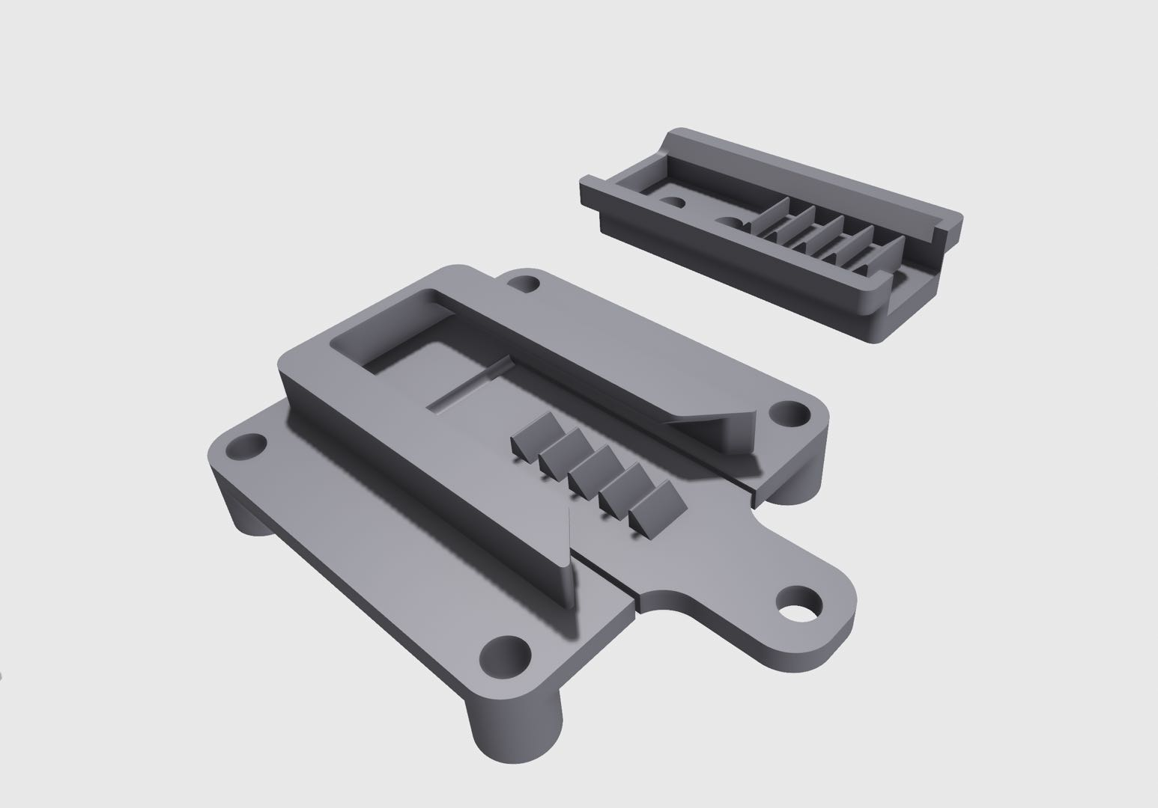

Fig.4 Mockups of opened Abseil

(2) Mechanical Arm:

1) Drawings:

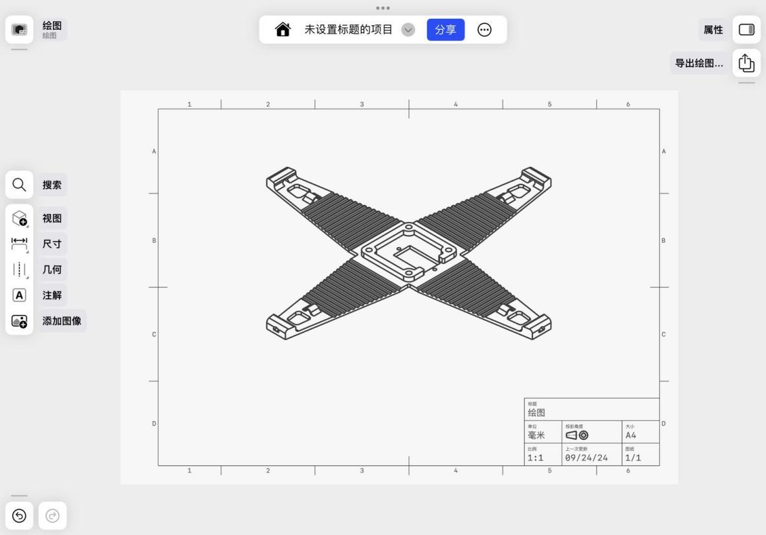

Fig.5 Drawings of Mechanical Arm

1. Mockups

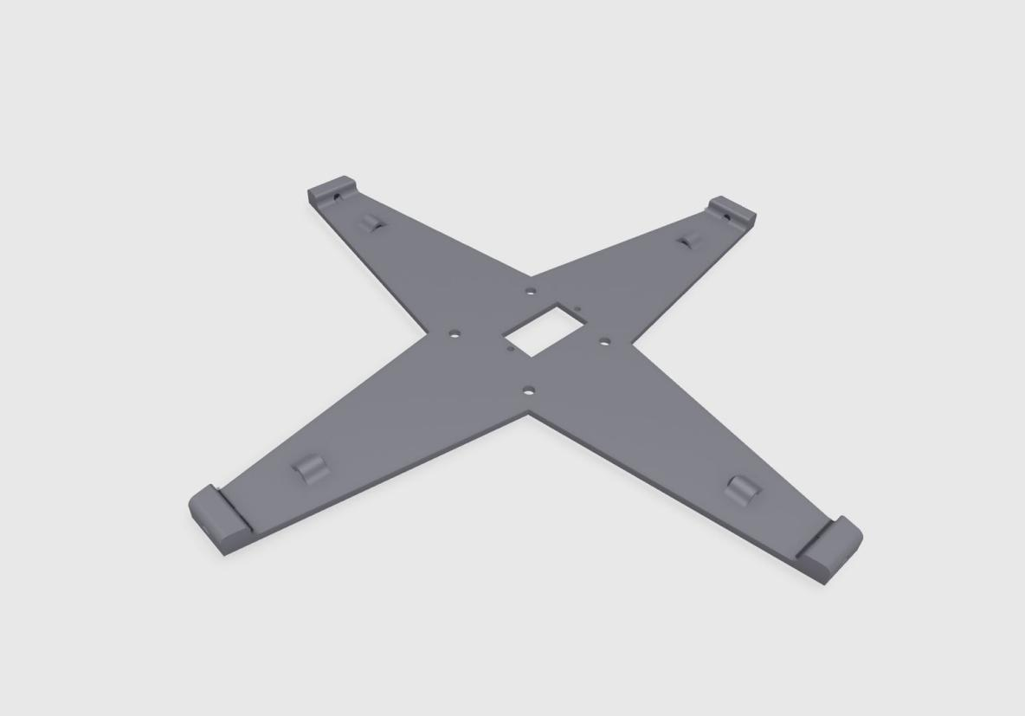

Fig.6 Mockups of Mechanical Arm

(3) Delivery Box:

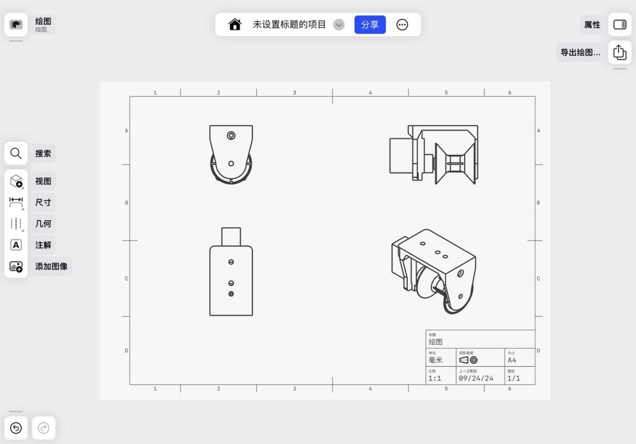1) Drawings:

Fig.7 Drawings of Delivery Box

1. Mockups

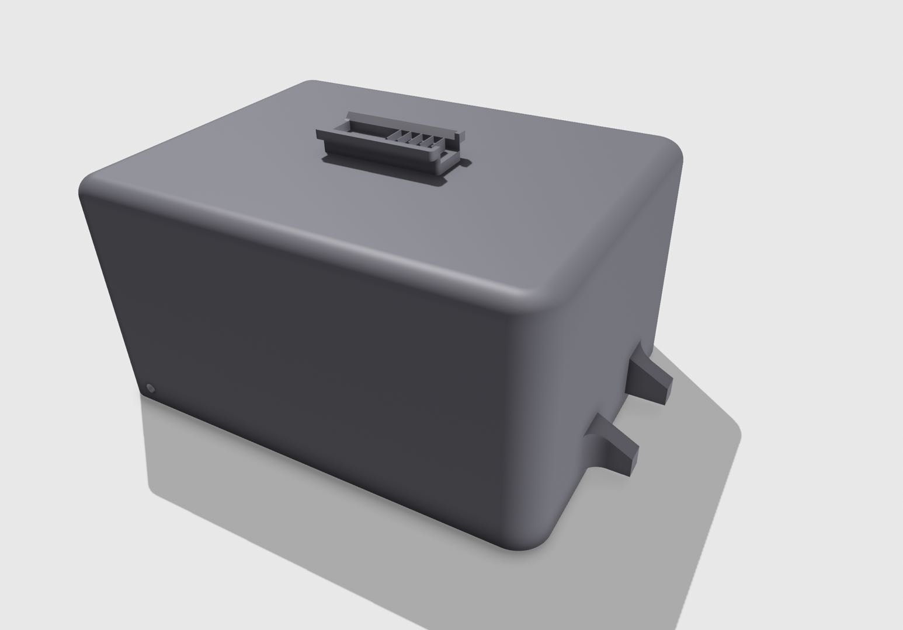

Fig.8 Mockups of Delivery Box

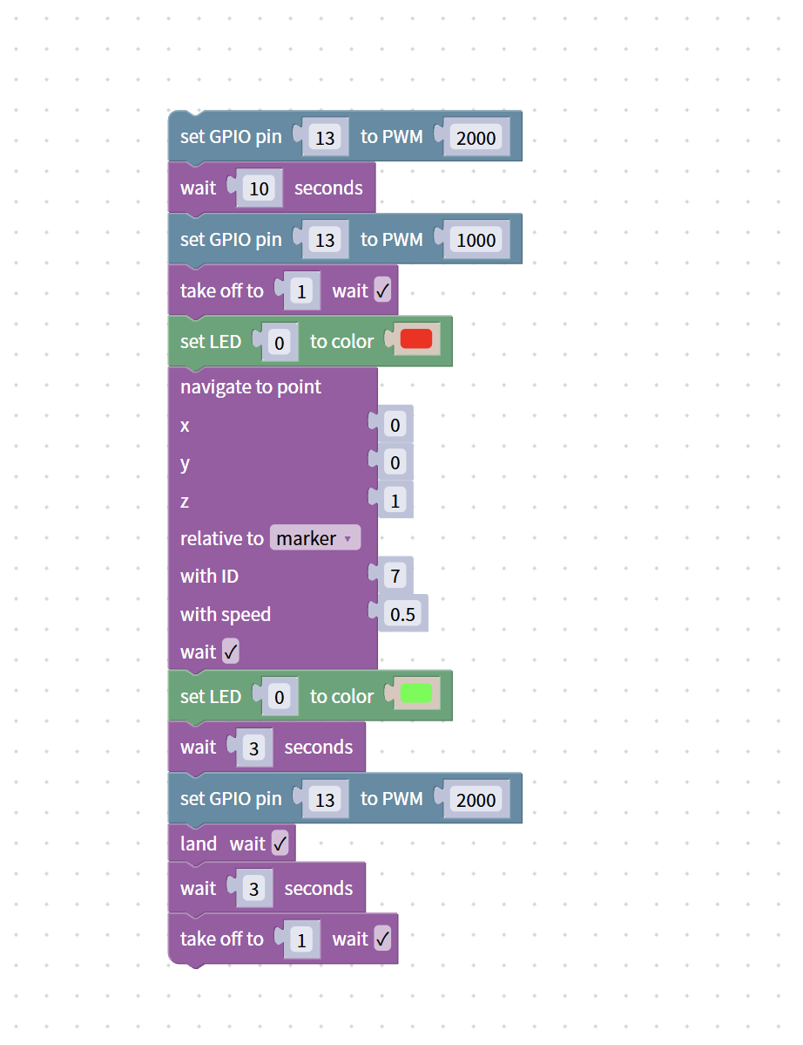3.Code

Fig.9 Code1-1

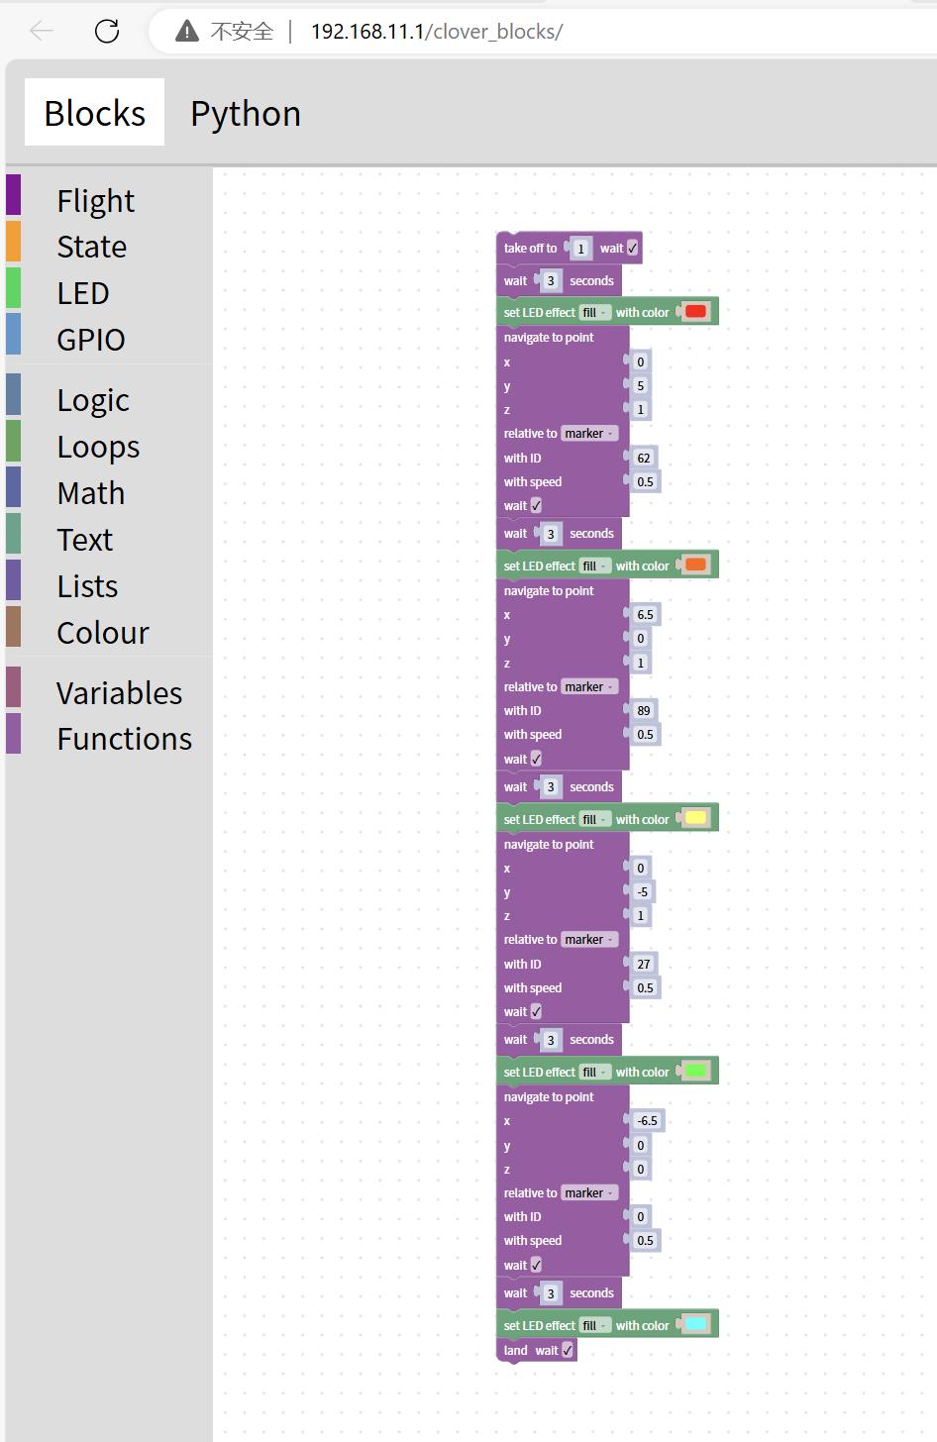

Fig.10 Code1-2

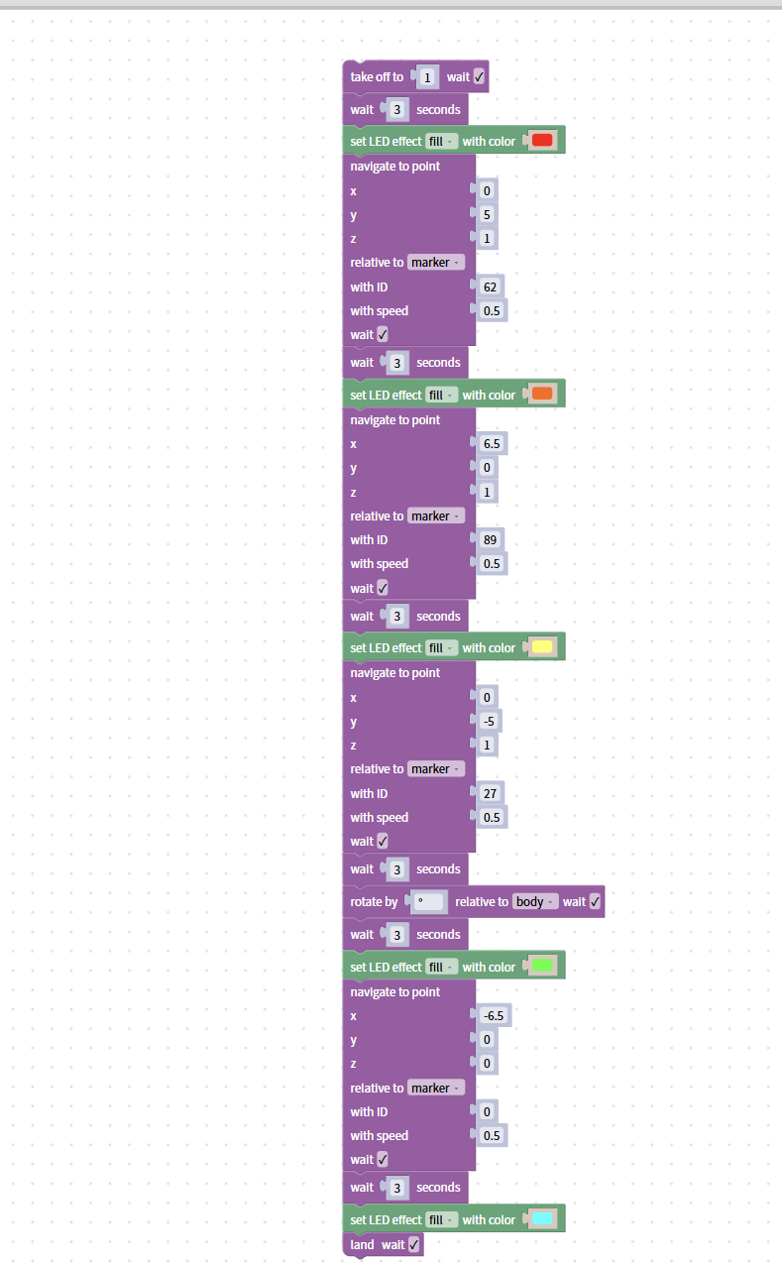

Fig.11 Code1-3

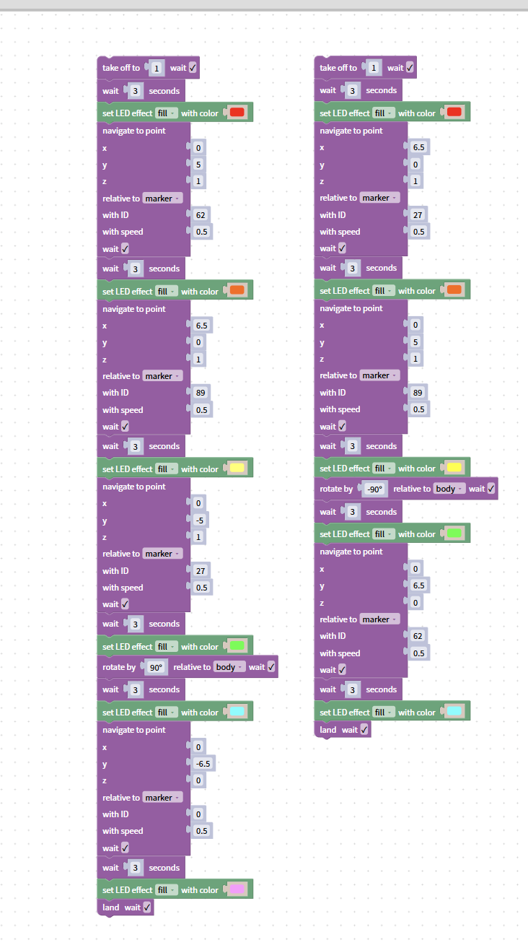

Fig.11 Code1-4